**package** 第一题;

**class** Student {

**public** Student() {

}; // 无参构造函数

**public** Student(String name, **int** score) // 有参构造函数

{

**this**.name = name;

**this**.score = score;

}

**public** **void** setname(String name) {

**this**.name = name;

}

**public** **void** setscore(**int** score) {

**this**.score = score;

}

**public** String getname() {

**return** **this**.name;

}

**public** **int** getscore() {

**return** **this**.score;

}

**private** String name; // 学生姓名

**private** **int** score; // 学生成绩

}

**public** **class** Student1 {

**public** **static** **void** main(String[] args) {

Student stu1 = **new** Student();

stu1.setname("zhangsan");

stu1.setscore(88);

System.***out***.println("stu1:name:"+stu1.getname());

System.***out***.println("stu1:score:"+stu1.getscore());

Student stu2 = **new** Student("lisi", 81);

System.***out***.println("stu2:name:"+stu2.getname());

System.***out***.println("stu2:score:"+stu2.getscore());

}

}

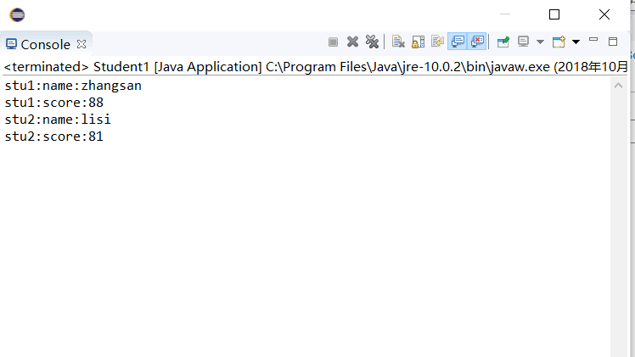

心得：构造函数可以重载为有参和无参，跟据实参的不同而调用不同的构造函数